SCHOOL OF COMPUTER SCIENCE AND ARTIFICIAL INTELLIGENCE |  |  |  |  | DEPARTMENT OF COMPUTER SCIENCE ENGINEERING
ProgramName:B. Tech |  |  |  | Assignment Type: Lab |  |  | AcademicYear:2025-2026
CourseCoordinatorName |  |  |  | Venkataramana Veeramsetty
Instructor(s)Name |  |  |  | Dr. V. Venkataramana (Co-ordinator)  Dr. T. Sampath Kumar  Dr. Pramoda Patro  Dr. Brij Kishor Tiwari  Dr.J.Ravichander  Dr. Mohammand Ali Shaik  Dr. Anirodh Kumar  Mr. S.Naresh Kumar  Dr. RAJESH VELPULA  Mr. Kundhan Kumar  Ms. Ch.Rajitha  Mr. M Prakash  Mr. B.Raju  Intern 1 (Dharma teja)  Intern 2 (Sai Prasad)  Intern 3 (Sowmya)  NS_2 ( Mounika)
CourseCode |  |  | 24CS002PC215 | CourseTitle |  | AI Assisted Coding
Year/Sem |  |  | II/I | Regulation |  | R24
Date and Day  of Assignment |  |  | Week4 - Wednesday | Time(s)
Duration |  |  | 2 Hours | Applicableto  Batches
AssignmentNumber:7.3(Present assignment number)/24(Total number of assignments)
 | Q.No. | Question |  |  |  |  |  | ExpectedTime  to complete
 | 1 | Lab 7: Error Debugging with AI: Systematic approaches to finding and fixing bugs  Lab Objectives:  - To identify and correct syntax, logic, and runtime errors in Python programs using AI tools.  - To understand common programming bugs and AI-assisted debugging suggestions.  - To evaluate how AI explains, detects, and fixes different types of coding errors.  - To build confidence in using AI to perform structured debugging practices.  Lab Outcomes (Los):  After completing this lab, students will be able to:  - Use AI tools to detect and correct syntax, logic, and runtime errors.  - Interpret AI-suggested bug fixes and explanations.  - Apply systematic debugging strategies supported by AI-generated insights.  - Refactor buggy code using responsible and reliable programming patterns.  Task Description#1  - Paste a function with a missing colon (add(a, b)), and let AI fix the syntax error.  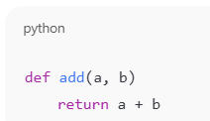  Expected Output#1  - Corrected function with syntax fix  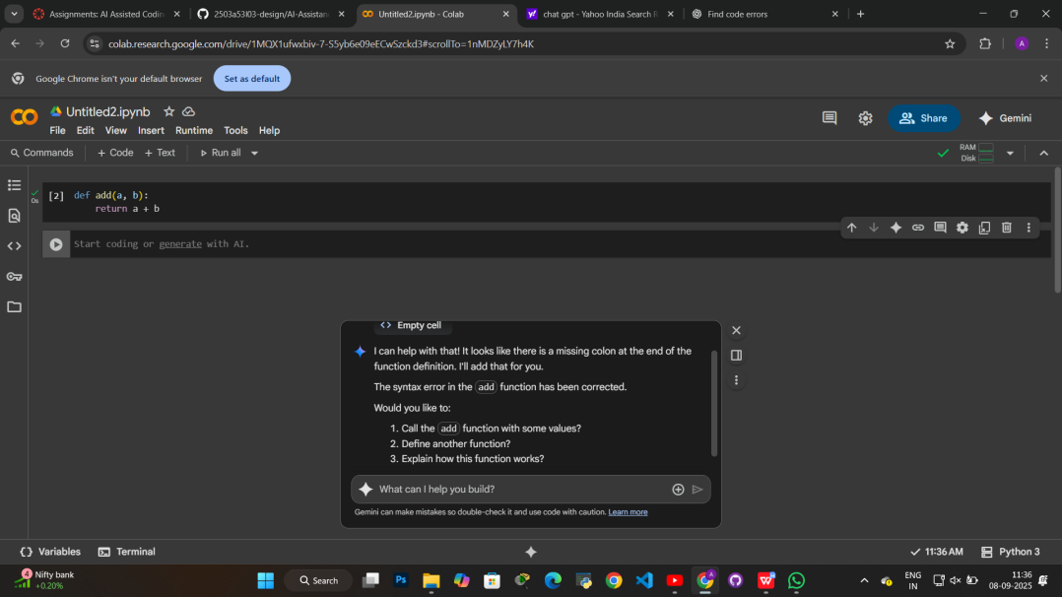  Task Description#2 (Loops)  - Identify and fix a logic error in a loop that causes infinite iteration.  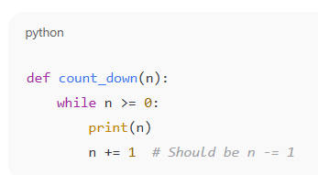  Expected Output#2  - AI fixes increment/decrement error  - 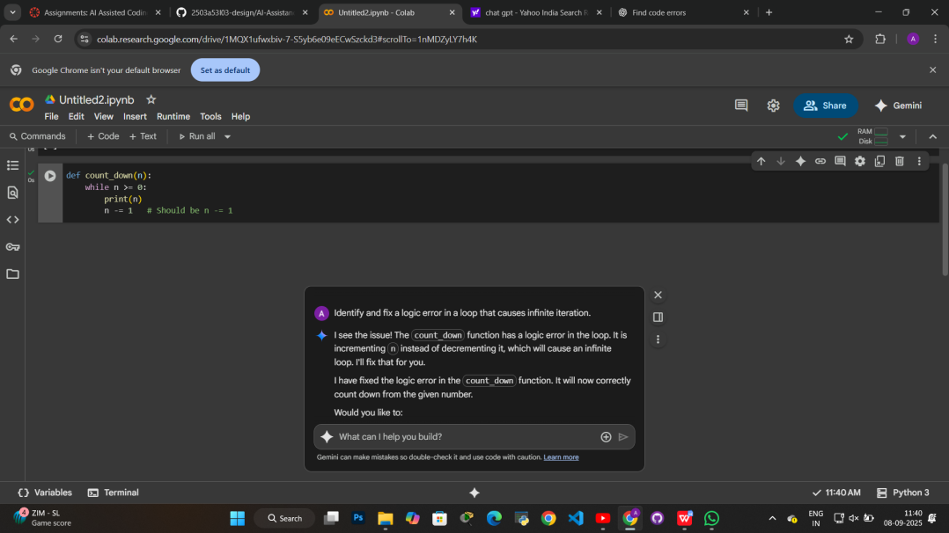  Task Description#3  - Debug a runtime error caused by division by zero. Let AI insert try-except.  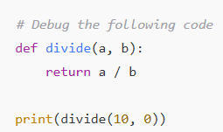  Expected Output#3  - Corrected function with safe error handling  - 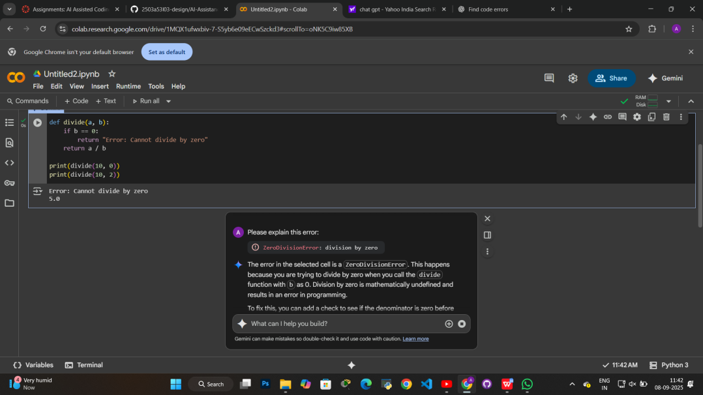  Task Description#4  - Provide a faulty class definition (missing self in parameters). Let AI fix it  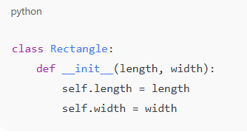  Expected Output#4  - Correct __init__() method and explanation  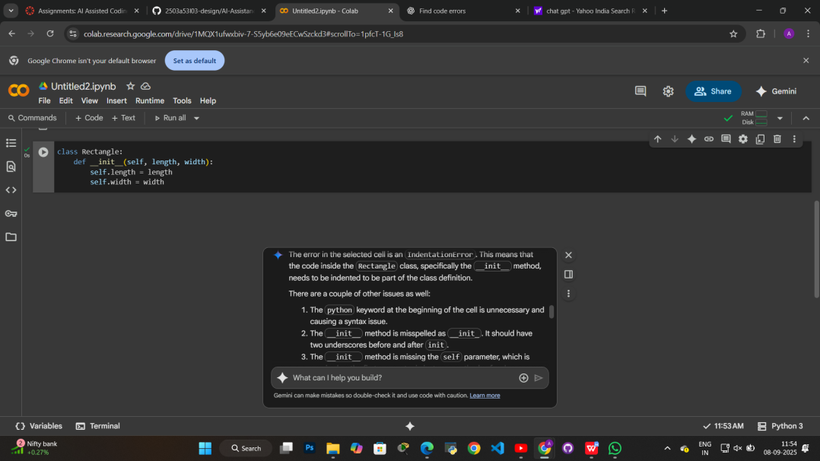  EXPLINATION:  - class Rectangle:: This line declares a new class named Rectangle. A class is a blueprint for creating objects (instances). In this case, the Rectangle class will be used to create objects that represent rectangles.  - def __init__(self, length, width):: This defines a special method within the Rectangle class called __init__. This is the constructor method. It's automatically called when you create a new Rectangle object.  - self: This is a reference to the instance of the class being created. It's the first parameter of any instance method in Python.  - length and width: These are parameters that you pass when you create a Rectangle object. They represent the dimensions of the rectangle.  - self.length = length: This line takes the value passed for the length parameter when creating the object and assigns it to an attribute of the object called length. This means each Rectangle object will have its own length attribute.  - self.width = width: Similarly, this line takes the value passed for the width parameter and assigns it to the width attribute of the object.  In essence, this code defines how to create a Rectangle object, requiring you to provide a length and a width when you create one.  Task Description#5  - Access an invalid list index and use AI to resolve the Index Error.  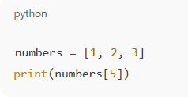  Expected Output#5  - AI suggests checking length or using safe access logic  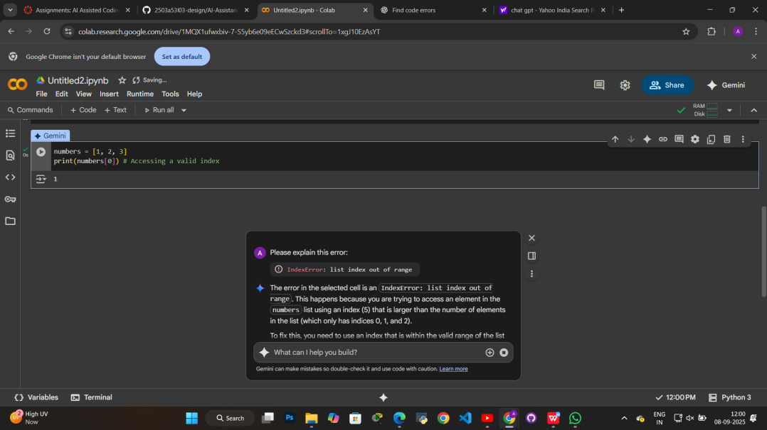  Note: Report should be submitted a word document for all tasks in a single document with prompts, comments & code explanation, and output and if required, screenshots  Evaluation Criteria:  Criteria Max Marks  Identification of bugs 0.5  Application of AI-suggested fixes 0.5  Explanation and understanding of errors 0.5  Corrected code functionality 0.5  Report structure and reflection 0.5  Total 2.5 Marks |  |  |  |  |  | Week4 – Wednesday
:

